|  |  |
| --- | --- |
| Course Name | ITD 2313 – Script Programming |
| Instructor | Mark L. Pranger |
| Student Name | Thomas Webb |
| Due date | 5/4/2025 |
| Grade | Put grade earned here |
| Grading Comments | Put instructor comments here |

Page 17 Exercise

Page 18 Exercises

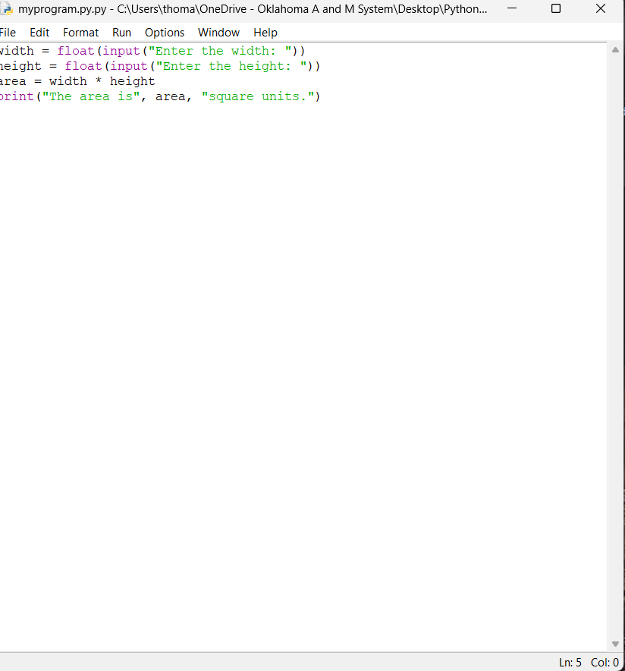

Page 20 exercise

Execrise 1-3 page 21 execrise

1: pyhton see’s it as text and Will loop and will display the Text as “greetings”

2: name = input("Please enter your name: ")

3: it’s a file that contains short and simple instructions that can be executed

Fixed code and Showing its operational  
Length = int(input (“Enter the length: “))

Page 22 execrise